MEASUREMENT SHEET
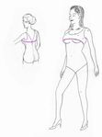 | 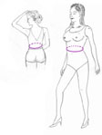 | 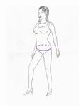 | 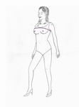 | 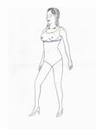
1. Bust : | 2. Waist : | 3. Hip : | 4. Upper Bust : | 5. Under Bust :
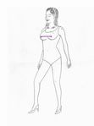 | 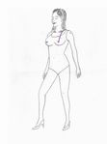 | 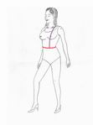 | 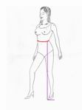 | 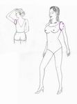
6. Bust Point : | 7. Shoulder  to Bust: | 8. Shoulder  to Waist : | 9. Waist  to Floor: | 10. Arms eye :
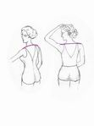 | 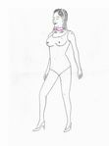 | 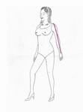 | 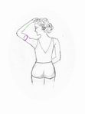 | 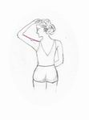
11. Shoulder  Width: | 12. Neck : | 13. Arms  Length : | 14. Biceps : | 15. Upper Arm Length :
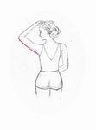 | 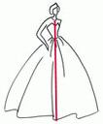
16. Length of  armpit  to elbow: | 12. Hollow  to hem

- Please note down each measurement in inches

- Decide the height of the shoe heel you will be wearing with your bridal gown and make sure to mention it separately under the relevant space. Do not add it to your height.

- Full Bust - ________

Measure around the fullest part of the bust

- Waist - ________
Firstly tie a piece of ribbon or string around the natural part of your waist. This would be your torso at the smallest point. Leave the string in place while you do the rest of your measurements as you will need it for reference with some of the other measurements

- Hips - ________

Take the measurement around the hips at the fullest point, take note of how far down from the waist that you are measuring.

- Upper bust - ________

Measure above your breast as shown in the diagram.

- Udder bust - ________

Measure under the breast as shown in the diagram.

- Nipple to nipple - ________

Measure across the bust nipple to nipple.

- Length of Should to bust - ________

Measure from the top of your shoulder to the nipple.

- Front Length Shoulder to Waist - ________

Measuring from the same point on your shoulder, go down over the top
of your nipple to the waist.

- Waist to Floor - ________

Measure from the string/ribbon around your waist to the floor. Please ensure you have a shoe similar in height to those you intend to wear on your wedding day.

- Arms eye - ________

This measurement gives us the size of the sleeve hole that you are comfortable wearing. This measurement is entirely subjective and you can make it as deep or as tight as you are comfortable with.

- Shoulder to Shoulder - ________

From the edge of the shoulder socket, measure all the way over to the same point on the other shoulder along the back, as shown in the diagram.
- Neck - ________

Measure loosely around the neck. You will not need this measurement unless your garment has a high neck or collar.

- Arm Length - ________

Measure from your shoulder point to the wrist. Also give measurement with your elbow bend, should be about an inch longer.

- Biceps - ________

Position your arm as the diagram, now measure the fullest part of the arm.

- Upper arm length - ________

Measure from the outer shoulder down to the elbow.

- Length of armpit to elbow - ________

Measure the outside of your arm from the armpit to the elbow

- Hollow to hem - ________

Measure from the hollow of your neck to the hem of where you want your dress to come to. Stand very straight when taking this measurement.

- Height of the shoe heel - ________

Keep the shoe on a flat surface and measure the height of the heel

